**Technological University of the Philippines**

**COLLEGE OF SCIENCE**

**Ayala Boulevard, Manila**

**Approval Sheet**

This thesis hereto entitled:

**EUREKA: VIRTUAL LEARNING CLASSROOM**

Prepared and submitted by **PAULINE D. ESCALONA, ADRIAN S. FELIX** and **JANNIE JOYCE G. PALLERA** in partial fulfillment of the requirements for the degree Bachelor of Science in Computer Science has been examined and is recommended for acceptance and approval for **ORAL EXAMINATION.**

**DARWIN C. VARGAS**

Adviser

Approved by the Committee on Oral Examination with a grade of **PASSED** on February 21, 2017.

**MARIA CARMELA F. FRANCISCO**Chairperson

**WELLANIE M. MOLINO FERNANDO L. RENEGADO** Member Member

Accepted in partial fulfillment of the requirements for the degree **Bachelor of Science in Computer Science.**

Date: **FIDELA Q. ARAÑES**  Dean

**Abstract**

The study developed the “Eureka: Virtual Learning Classroom” The objectives of the study are to create a computer generated virtual environment that allows a user to interact using the virtual reality headset with the Bluetooth controller; experience the demonstration of the solar system and the layers of the Earth, and learn with the accompanying lessons. The system was developed using Unity 3D, Blender, Metasequoia and Android Operating System. Thirty respondents composed of Grade 6 students and teachers from Las Piñas Elementary School-Central evaluated the program. Based on the results of the evaluation, the developed system gained an overall frequency score of 4, with a descriptive rating of “Highly Acceptable”.

**Acknowledgement**

We would like to express our deepest gratitude to the following people, who have guided us throughout the hardships and challenges of completing this thesis.

We would like to thank our Almighty God who gave us the knowledge in finishing this thesis, as well as the strength and patience throughout the school year.

We would also like to thank our family, for their never ending love, support and understanding, and also to our friends, for helping us out throughout this stressful semester.

Lastly, we would like to express our greatest appreciation to our thesis adviser, Mr Darwin C. Vargas, who has been patient in teaching and guiding us throughout the course of our thesis. This is a big thank you to our professor, thesis adviser, and our best supporter. Thank you, Sir!

- P. Escalona, A. Felix, J. Pallera

**Table of Contents**

|  |  |
| --- | --- |
|  | **Page** |
| Title Page | 1 |
| Approval Sheet | 2 |
| Abstract | 3 |
| Acknowledgment | 4 |
| Table of Contents | 5 |
| List of Tables | 7 |
| List of Figures | 8 |
| List of Appendices | 9 |

|  |  |  |
| --- | --- | --- |
| **Chapter 1 THE PROBLEM AND ITS SETTING** | |  |
|  | Introduction | 10 |
|  | Background of the Study | 11 |
|  | Objectives of the Study | 12 |
|  | Scope and Limitations of the Study | 13 |
|  | Significance of the Study | 14 |
| **Chapter 2 CONCEPTUAL FRAMEWORK** | |  |
|  | Review of Related Literature | 15 |
|  | Conceptual Model of the Study | 34 |
|  | Operational Definition of Terms | 36 |
| **Chapter 3 METHODOLOGY** | |  |
|  | Project Design | 37 |
|  | Project Development | 41 |
|  | Operation and Testing Procedure | 44 |
|  | Evaluation Procedure | 45 |
| **Chapter 4 RESULTS AND DISCUSSION** | |  |
|  | Project Description | 47 |
|  | Project Structure | 48 |
|  | Project Capabilities and Limitations | 52 |
|  | Test Results | 53 |
|  | Project Evaluation | 54 |
| **Chapter 5 SUMMARY OF FINDINGS, CONCLUSIONS, AND RECOMMENDATIONS** | |  |
|  | Summary of Findings | 57 |
|  | Conclusions | 57 |
|  | Recommendations | 58 |

|  |  |  |  |
| --- | --- | --- | --- |
| **References** | | | 59 |
|  | | |  |
|  |  |  |  |
|  |  |  |  |
|  |  |  |  |
|  |  |  |  |
|  |  |  |  |
|  | | |  |

**List of Tables**

|  |  |  |
| --- | --- | --- |
| **Table** |  | **Page** |
| 1 | Project Title, Description, and Case title | 41 |
| 2 | Use Case Modules | 42 |
| 3 | Testing Procedures | 44 |
| 4 | Test Results for Functionality, Reliability, Efficiency, and Usability | 53 |
| 5 | Respondent’s Frequency Rating | 55 |

**List of Figures**

|  |  |  |
| --- | --- | --- |
| **Figure** |  | **Page** |
| 1 | Vector Image | 24 |
| 2 | Conceptual Model of the Study | 34 |
| 3 | Use-Case Diagram | 38 |
| 4 | System Flowchart | 38 |
| 5 | Hierarchical Input Process Output | 39 |
| 6 | Application Development Flowchart | 43 |
| 7 | Classroom Interface | 48 |
| 8 | Interactive Menu | 48 |
| 9 | Loading Screen | 49 |
| 10 | Status Screen for the layers of the Earth | 49 |
| 11 | Layers of the Earth | 50 |
| 12 | Status Screen for the planets | 50 |
| 13 | Simulation of the Planetary Revolutions | 51 |
| 14 | “Gotta Catch ‘Em” Mini Game | 51 |
| 15 | Protect the Earth Mini Game | 52 |
|  |  |  |

**List of Appendixes**

|  |  |  |
| --- | --- | --- |
| **Appendix** |  | **Page** |
| A | Evaluation Sheet | 61 |
| B | Sample Answered Evaluation Sheet | 62 |
| C | Summary of Evaluation Sheet | 63 |
| D | Gantt Chart | 64 |
| E | User’s Manual | 65 |
| F | Curriculum Vitae | 68 |

**Chapter 1**

**THE PROBLEM AND ITS SETTING**

**Introduction**

Education has been helping us in making our lives better especially the youth. From generation to generation, education is needed to prepare the people in their choice of career. As generations move forward, technology advances and so should education. Different methods of teaching the young generation are necessary and must also satisfy them by integrating technology into education. One important subject in education is Science. Science made the foundation for many studies and researches, from medicine to machinery and more. As science is one big umbrella, one must start with the basics to make it easier to comprehend.

One interesting topic in science is astronomy. It is the scientific study of stars, planets, and other objects in outer space. As the universe is massive, we tend to appreciate more discoveries in the field of astronomy. It also helps these discoveries to adapt and develop new innovations for future use. Astronomy has been taught to the children in the Philippines that are in their 6th grade. As the new education system K-12 is introduced, pupils in their 6th grade will get to learn the latest discoveries in the field of astronomy. However, due to expensive equipments needed to study Astronomy such as telescopes, teachers rely only on textbooks and dioramas that can emulate the universe for their pupil’s observation. This hinders the integration of technology to the education of the new generation of pupils. In response to this problem, the researchers decided to create an interactive software application that can be used by pupils to learn more about astronomy through the use of Virtual Reality (VR) technology.

**Background of the Study**

The main problem of the study is that Astronomy is an integral subject for students to study that comes with expensive equipment for observation and because of it, pupils are less likely to experience interaction with the subject and neglecting its importance due to lack of interaction. In comparison to other fields of science that are observable in laboratories, astronomy is observed in space and because of the lack of equipment, teachers decided to rely on presentation which makes it less appealing because pupils aren’t likely to interact with the subject. The children also get easily bored with just face to face verbal learning and long hours of lectures in the topic.

The Grade 6 students, who study basic astronomy, find themselves hard to discover the planets and the solar system itself since they have little to no interaction with this topic. Sometimes these students pay expensive for their planetarium tour but learn less for it since the tour is either just for a short time or there is less interaction. In response to the problems stated earlier, the researchers intended to develop a mobile application for children and students especially for Grade 6 Students which can be an additional help to learn and appreciate basic Astronomy Science based on K-12 program of Department of Education(DepED) powered by Virtual Reality technology. With the use of this application, children can foster the basic concepts of Science and find practical uses and applications in the field, and as well to motivate them in this subject matter and have creative interaction and entertainment too.

**Objectives of the Study**

The objective of the study is to develop “Eureka – Virtual Learning Classroom”: An Android Based E-Learning Application that will help students to learn in interactive way the basic topics and lessons on basic astronomy based on the Grade 6’s K-12 program of DepED. It will tackle specifically the Earth layers and planets in the solar system and their size and distance to each other. It will also help the teachers to have a creative way of teaching the students by means of technologies.

Specifically it aims to:

1. Design the system with the following features:
   1. Computer generated virtual environment that allows interaction using the VR Box and Bluetooth remote controller
   2. Classroom Interactive Main Menu.
   3. Interactive Earth Layers Lesson.
   4. Interactive Solar System Lesson
   5. Interactive Solar System Game and Challenge module.
2. Create the system with the following tools:
   1. Hardware components
      1. Virtual Reality Gear with Bluetooth remote controller
      2. Android Smartphone with the following specifications:
         1. Android 4.4 Operating System
         2. Gyroscope
         3. At least 2 gigabytes of RAM
   2. Software Components
      1. Unity 3D
      2. Blender
      3. Adobe Illustrator
      4. Adobe Photoshop
      5. Metasequoia
3. Test and improve the “Eureka” in terms of functionality, usability, reliability, and response time.
4. Determine the level of acceptability of the game through the following in terms of:
5. Functionality
6. Reliability
7. Usability
8. Efficiency

**Scope and Limitations of the Study**

The “Eureka – Virtual Learning Classroom” will mainly run on the Android phone using the Virtual Reality technology to interact and view the lectures and challenges for Earth layers and Solar System. The software must have complete hardware components in able to run the software. The teachers should also be knowledgeable on how the software and hardware works to have a good flow of the lectures using the mobile application. It runs on Android Operation System. It will only discuss the Earth layers and Solar System lesson which is based under the Department of Education K-12 program curriculum for Grade 6. The application does not support multiplayer feature.

**Significance of the Study**

The purpose of the Development of Eureka – Virtual Learning Classroom: An Android Based E-Learning Application using Virtual Reality Technology is to make the education more enjoyable and interactive for the students. It will lessen the face-to-face verbal teaching and long hours of lectures that makes the students bored and not interested in the subject matters. It will also allow them discover the lessons and interact face to face with the topics that they can only grasp on costly educational trips.

**Chapter 2**

**CONCEPTUAL FRAMEWORK**

This chapter contains the review of related literature, studies, conceptual model of the study, and the operational definition of terms.

**Review of Related Literature**

This includes the related literature and studies that are relevant to the development of the application.

***Virtual Reality (VR)***

According to LaValle (2015), Virtual Reality (VR) is stimulating targeted behavior in an organism by using artificial sensory stimulation while having little or no awareness of the interference. Since the sensory organs are manipulated in such way, the perceived environment is associated with the desired Virtual Environment and not with the physical one. This manipulation process is controlled by a computer model that is established on the physical description of the virtual environment. So, the technology is able to generate almost arbitrarily perceived surroundings (Thalmann, 1999).

Virtual Reality is the application of computer technology to generate a simulated environment. Unlike the conventional user interfaces, VR places the user inside an experience. Instead of viewing the computer screen in front of them, users are now able to interact with 3D worlds that are generated by the computer. By stimulating as much senses as possible, such as vision, hearing, touch, even smell, the computer served as a medium to an artificially generated environment (Jackson, 2015)

The researchers decided to incorporate Virtual Reality in this study for it is enables the emulation of the environment that is included in the application and also allows the user to immerse with the application and its features.

***Augmented Reality (AR)***

According to Cawood and Fiala (2008), The goal of augmented reality (AR) is to create the sensation that virtual objects are present in the actual world. It is most effective when virtual elements are included in real time. AR commonly involves augmenting 2D or 3D objects to a real-time digital video image.

Augmented reality originated in 1968 when Ivan Sutherland created a functional prototype which was considered as the first VR system and the first AR system. It only used simple wire-frame graphics, but this project was considered the birth of AR. Sutherland’s system required that the user must wear a cumbersome HMD (Head-Mounted Three-Dimensional Display) that is suspended from the ceiling due to its heavy weight.

Applications using AR technology incorporate virtual objects with a 3-D real environment in real time (Milgram and Kishino, 1994; Azuma, 1997). Together, virtual and physical objects appear in a real time system in a way that the user sees the real world and the virtual objects superimposed with the real objects. In this way, the user’s perception of the physical world is enhanced and the user interacts in a more natural way (Figueiredoet al, 2013)

Since augmented reality is the combination of virtual reality and real life, integrating virtual elements in the real world is one of the intentions of the researchers in the development of this study. A brief knowledge about this field allows the researchers to improve the application even better.

***Video Game***

Video game is any game that integrates human interaction with a user interface to create visual feedback on a video device. It can also be defined as “a game which we play with the help of an audiovisual apparatus and which can be based on a story” (Esposito, 2016). Technically, in order for a product to be a video game, there must be a video signal to be transmitted to a cathode ray tube (CRT) that creates a rasterized on a screen Today, the term “video game” encompasses any game played on hardware built with electronic logic circuits that has an element of interactivity bonus and displays the results of the player’s actions to a display (Wolf, 2007).

The first video game was invented in the United States Department of Energy. In 1958 the first video game was assembled, and the result was “Tennis for Two”. It was designed to be an exhibit in the gymnasium of the laboratory in the Department of Energy (Rabin, 2010)

Incorporating some concepts about video games allows the researchers to expand their knowledge about the matter and to develop games included in the application, which will then test the user’s understanding of the lessons included.

***Unity3D***

In an article made by Ian Zamojc (2012), Unity3D is a powerful cross-platform 3D engine and a user friendly environment. According to the article, it is easy enough for a beginner and powerful enough for an expert. It is applicable to anyone who wants to easily create 3D games and applications for different platforms such as mobile, desktop, the web, and consoles. Unity is free to use for everyone, but there is a Pro edition that includes more features and tools, it costs $1,500 (71199.75PHP). Applications published under the free edition will have a small Unity watermark, while the Pro version will have none.

The Unity application is a complete 3D environment, apt for laying out levels, creating menus, doing animation, writing scripts, and organizing projects. The user interface is well organized and the panels are customizable by dragging and dropping. Unity supports three different programming languages; UnityScript, C#, and Boo. UnityScript is similar to JavaScript and ActionScript, C# has the same semantics as Java, and Boo is similar to Python. These provides more choices for developers who are familiar with different programming languages, since Unity is not fixated in one programming language only. It is able to publish to Windows, OS X, and the web via the Unity Web Player (a browser plugin that works in all major browsers), while Unity Pro can publish to even more platforms.

Unity is chosen by the researchers since it is one of the most reliable 3D game engine that will function as the main IDE for the development of the application. For it does not only function as a 3D environment that is preferable for doing animations and incorporating 3D assets in the application, it also where the researchers will do most of the coding.

***Blender***

Blender is a free and open source 3D creation suite. It is used for creating animated films, visual effects, art, 3D printed models, interactive 3D applications and video games. Developed by Blender Foundation, its initial release was on January 1995, written in C, C++, and Python languages. It features include 3D modeling, UV unwrapping, texturing, raster graphics editing, rigging and skinning, fluid and smoke simulation, particle simulation, soft body simulation, sculpting, animating, match moving, camera tracking, rendering, video editing and compositing. It also integrates a game engine.

It was initially developed by the Dutch animation studio Neo Geo as an in-house application in January 1995, with the primary author being software developer Ton Roosendaal. On July 18, 2002, Roosendaal started a campaign aimed for open-sourcing Blender for a one-time payment of €100,000 (US$100,670 at the time) collected from the community. On September 7, 2002, it was announced that they had collected enough funds and released the source code for the software. Today, Blender is a free, open-source software that is – apart from the Blender two full-time and two part-time employees – developed by the community.

The researchers felt most comfortable using Blender for being user friendly, hence developing assets and 3D models for the application is much easier, rather than using a software that is more challenging to handle. Using Blender allows the researchers to add textures, shadows, and different effects to the assets that serves as an important part in developing the application.

***Adobe Illustrator***

Adobe Illustrator is a vector graphics editing software developed and marketed by Adobe Systems. It is used mostly by graphic designers and artist to create vector images. These vector images are used as logos, illustrations, graphics, and animation assets. Aside from these, website mockups can also be created with the use of Illustrator. It is also possible to import vector graphics into Adobe Flash and After Effects in order to animate them. It is not only for vector images, but as well as raster image files. Though Illustrator may come as an intimidating software, the basics can be easily learned in a short span of time.

Adobe Illustrator was initially released on the 29th of March 1987. It was then first developed for the Apple Macintosh in December 1986 as the companion of Adobe Photoshop. Since Photoshop was designated mainly for digital photo manipulation, Illustrator was for typesetting and logo graphics and design. In 2003, Adobe released Illustrator CS (Creative Suite), which was the first version to include 3-dimensional capabilities, which allows the user to revolve shapes in order to create simple 3D objects. Version CS6 was the last installment of the Illustrator CS series and Illustrator CC was its successor. Illustrator CC (Creative Cloud) is the 17th version of Adobe Illustrator to be released. It was the first to be only sold in a subscription-based service model. Illustrator CC has added features such as saving documents to the cloud, integration with Behance, touch-compatible type tool, images in brushes, CSS extraction, and file packaging.

Adobe Illustrator is preferred by the researchers for its familiarity. The researchers are accustomed to Illustrator CC and it is the ideal software to create vector graphics that will be used in the development of the application.

***C#***

According to Svetlin Nakov (2013), C# is a modern object-oriented, general-purpose programming language, created and developed by Microsoft together with the .NET platform. There are many applications that can be developed using C# and on the .NET platform, such as, office applications, web applications, websites, desktop applications, mobile applications, games, and many more. It is a high-level programming language that is similar to Java and C++ and, to some extent, Delphi, VB.NET., and C. All programs created with C# are object-oriented as they consist of a set of definitions in classes which contain methods and these methods contains the logic of the program.

C# is one of the most well-known programming language, since it is used by millions of developers worldwide. Because it is developed by Microsoft as part of their modern platform, the language is widely spread among Microsoft-oriented companies, organizations, and individual developers. C# language and the .NET platform are exclusively maintained and managed by Microsoft and are not open to third parties.

***3D Modeling***

3D modeling is the integration of software to develop a virtual three-dimensional model of a physical object. Used in different industries, including virtual reality, video games, 3D printing, marketing, TV and motion pictures, scientific and medical imaging and computer aided design and manufacturing CAD/CAM (Rouse, 2016). It is the process of developing a mathematical representation of any three-dimensional surface of an object via specialized software, the product is then called a 3D model. It can be exhibited as a two-dimensional image by undergoing a process called 3D rendering or when simulated with a computer of physical phenomena. The model can also be physically created 3D printing.

The researchers will be modeling 3D figures in order to create assets needed for the application. These 3D modeling will allow better and realistic assets that will be important in the integration of the VR environment with the user.

***Animation***

Animation is art in movement. The illusion of movement in animation is created by a physiological phenomenon called persistence of vision. It is the process of making the illusion of motion and change, as Bob Thomas cited. By displaying a rapid sequence of static images that minimally differ from each other.

Animation can be recorded with either analog media, a flip book, motion picture film, video tape, digital media, including formats like GIF, Flash animation and digital video. These are displayed by the use of digital cameras, computers, or projectors, as well as newly produced technologies. There are different approaches in animation, namely: traditional animation, stop motion animation, computer animation, mechanical animation, and such.

The researchers will be incorporating animation in the study, for this will play an important role in making the application lively and interactive.

***Vector Graphics***

Vector graphics is the creation of digital images through a sequence of commands or mathematical statements that place lines and shapes in a given two-dimensional or three-dimensional space. Instead of containing a bit in the file for each bit of a line drawing, vector graphics describes the series of points to be connected, thus, resulting in a much smaller file compared to bitmap images. Vector files are sometimes called a geometric file. It is much easier to modify compared to raster image files (Rouse, 2016).

In animation, vector files are usually preferred, since they display better quality rather than using a raster file. Because vector-based images are not composed of specific number of dots, they can be scaled into a larger size and the quality of the image is not compromised. Raster graphics on the other hand, will appear blocky, or “pixelated”. When vector graphics are zoomed in or stretched in a larger scale, the edges the object will stay smooth. Common types of vector graphics include Adobe Illustrator, Macromedia Freehand, and EPS files. Figure 1 shows the difference between vector image and raster image.

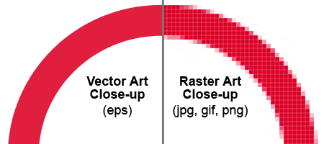

***Figure 1.*** Vector image file in .EPS and raster image file

***Computer Simulation***

Computer simulation is a recreation, run on a single or network of devices or computers, to imitate the behavior of a system. It uses a computer model, or a computational model to simulate the action of the system. Computer simulations played a useful part in different fields when it comes to mathematical modeling of natural systems. Physics, astrophysics, climatology, chemistry and biology, human systems in economics, psychology, social science, and engineering are just some of the fields that tapped computer simulation to identify and relate data.

Computer simulation, also has different meanings as the one mentioned above. It can refer to a computer program that simulates an abstract model so that it can be analyzed (as mentioned before). It can also pertain to a 3D computer graphic model in order to represent a three-dimensional object by using a special software. Lastly, it can refer to as emulation, in which the behaviors and function of a particular system are reproduced on a second system.

According to Eric Winsberg (2015), computer simulation is a program that is run on a computer and uses step-by-step methods to explore the approximate behavior of a mathematical model. Most models are referred to as a model of a real-world system. Such a computer program is a computer simulation model. An algorithm is then run when the system is executed, thus producing a numerical picture of the evolution of the system’s state, as it is conceptualized in the model.

In the form of 3D models, computer simulation are used in health care, the sciences, architecture, and in motion pictures, computer games, and video games. These 3D models take one of two approaches. They may show an object as a solid, defining it by its volume. The alternative is showing the boundary or shell of an object or asset. The latter is the predominant model for games and film. These objects are mostly based entirely on very basic geometric shapes. Computer modeling would uses balls, cubes, and pyramids (e.g. 3D Figures).

***Mobile Application***.

It is a program designed to perform a group of coordinated functions, task, or activities for the user, integrated into a handheld mobile device. It can be bundled with the device and its system software or purchased or downloaded separately. It can be coined as propriety, open-source or university projects. Applications that are not preinstalled are available through application distribution platforms and are typically operated by the owner of the operating system of the mobile device, such as the Apple App Store, Google Play, Windows Phone Store, and BlackBerry App World. As mentioned earlier, some apps are free, while others need to be purchased.

The term "app" is short for the term "application software". Pogue (2009) stated that newer smart phones can be coined as "app phones" to distinguish them from earlier less sophisticated smart phones.

Development of mobile applications requires special IDEs. They are first tested with emulators, running on desktop computers and then subjected to field testing. UI plays a crucial role in developing a mobile up for it considers the constraints and contexts included in the design. The user focuses on the interaction with their mobile device as it entails both hardware and software components.

***Smart phone***

A smart phone is a cellular telephone with an integrated computer and other features that are not originally included with telephones, like operating system, Web browsing, and the ability to run software applications. Smart phones are usually pocket-sized together with the features of a cellphone, such features are placing and receiving voice calls and creating and receiving text messages, also included are abilities of other popular digital mobile devices like personal digital assistants (PDAs), such as an event calendar, media player, video games, GPS navigation, digital camera, and digital video camera.

In an article published in Bloomberg News’ website, IBM created the first smart phone, named Simon. It debuted in August 16, 1994, with the features of a cellphone combined with a pager, fax machine, and computer, packed into an 8-inch device, weighing 510 grams with a memory of 1 MB, as well a 1 MB storage. Its input is a touch screen that is capable of accessing email and sending faxes (Sager, 2012).

The researchers included smart phones in the study since the VR equipment to be used are made for smart phones. Also, the application can only be executed with a smart phone.

***Oculus Rift***

Oculus Rift is a VR headset developed and marketed by Oculus VR, it was first released on March 28, 2016, with an introductory price of $599. It has an OLED display, with 1080x1200 resolution per eye, a 90 Hz refresh rate, and 110° field of view (Atman, 2015). It is also integrated with headphones which provides a 3D audio effect, rotational and positional tracking.

The first prototype was made together in 2011 by Palmer Luckey in Long Beach, California. John Carmack has been doing his own research as well about head-mounted display for gaming. In 2012, during the E3 convention, Carmack introduced a duct taped head-mounted display based on Luckey’s Oculus Rift prototype, running in his own software. Since then Oculus Rift has progressed vastly due to the rapid innovation in the VR industry.

***Android Operating System***

Android is a mobile operating system (OS) currently developed by Google, based on the Linux kernel and designed primarily for touch screen mobile devices such as smart phones and tablets. Android's user interface is based on direct manipulation, using touch gestures that loosely correspond to real-world actions, such as swiping, tapping and pinching, to manipulate on-screen objects, along with a virtual keyboard for text input. In addition to touch screen devices, Google has further developed Android TV for televisions, Android Auto for cars and Android Wear for wrist watches, each with a specialized user interface. Variants of Android are also used on notebooks, game consoles, digital cameras, and other electronics. As of 2015, Android has the largest installed base of all operating systems. It is the second most commonly used mobile operating system in the United States, while iOS is the first.

Initially developed by Android, Inc., which Google bought in 2005, Android was unveiled in 2007, along with the founding of the Open Handset Alliance — a consortium of hardware, software, and telecommunication companies devoted to advancing open standards for mobile devices. As of July 2013, the Google Play store has had over one million Android applications ("apps") published, and over 50 billion applications downloaded. An April—May 2013 survey of mobile application developers found that 71% of developers create applications for Android, and a 2015 survey found that 40% of full-time professional developers see Android as their priority target platform, which is comparable to Apple's iOS on 37% with both platforms far above others. At Google I/O 2014, the company revealed that there were over one billion active monthly Android users, up from 538 million in June 2013.

Android's source code is released by Google under open source licenses, although most Android devices ultimately ship with a combination of open source and proprietary software, including proprietary software required for accessing Google services. Android is popular with technology companies that require a ready-made, low-cost and customizable operating system for high-tech devices. Its open nature has encouraged a large community of developers and enthusiasts to use the open-source code as a foundation for community-driven projects, which add new features for advanced users or bring Android to devices originally shipped with other operating systems. At the same time, the lack of centralized update services has led to many devices never receiving updates: A 2015 research concluded that almost 90% of Android phones in use had known but unpatched bugs. The success of Android has made it a target for patent litigation as part of the so-called "Smartphone wars" between technology companies.

The researchers intended the program to run on Android OS, since it’s one of the leading smart phone operating system available. It is also very accessible, since most Android smart phones running on Android OS is quite inexpensive, compared to its competitors. In addition to this, developing Android applications is free.

***Android SDK***

Android SDK uses Java Android Library, similar to Java Standard Edition (J2SE). The syntax is the same as Java in terms of operands, selections, iterations, file handling and more. It is mandatory to Android developers. It contains all the packages, application framework and class libraries every Android application developer needs.

It is an Open Source platform and the first version is released in 2008 as the GI phone was produced by HTC. In the next two years, 4 versions of Android came out. In 2010 there were at least 60 devices running on the Android Operating System.

Until around the end of 2014, Eclipse IDE fully supported the Android SDK using the Android Development Tools Plug-in and also NetBeans IDE also supports the product via a plug-in. The SDK supports older versions of the Android platform just in case developers want to target their applications at devices running on older version of the Android operating system. Android applications have a file format .apk. The .apk package contains .dex files (a compiled byte codes called Dalvik executables), resource files, and many more, according to Skogberg (2010).

The researchers need to install the Android SDK since it is a prerequisite of Unity when building the application. This is important because it allows the code to build and run any code in an Android device.

***Astronomy***

Astronomy can be simply put as the study of anything beyond the Earth or non-Earth heavenly bodies and phenomena (Vogt, 2001). The word ‘astronomy’ originated from the Greek word “ἀστρονομία” (*astronomía*) from “ἄστρον” (*astron*), which means “star” and “ –νομία” (*-nomia)* which means, “law” or “culture”. Taking the Greek meaning, astronomy means the “culture of the stars”. Not to be confused with astrology, which is defined as the belief system which claims that human situations are concurrent with the location of heavenly bodies (Losev, 2012). Granting these two subjects share the same origin, they are now entirely distinct (Unsöld, 2001).

Based on the K-12 Science Curriculum Guide prepared by the Department of Education (DepEd), 6th Grade astronomy focuses on the Earth and other natural objects in space. Included in the astronomy module are the motions of the Earth: revolution and rotation. Students will also be able to identify the different members of the Solar System and their distinct features.

***Solar System***

The Solar System is the gravitationally bound system consisting of the Sun and the heavenly bodies that orbit it, directly or indirectly. It is located in an outer spiral arm of the Milky Way. The solar system also includes the Kuiper Belt which is located in the Neptune’s orbit. Formation of the solar system occurred about 4.5 billion years ago, starting from a dense cloud of gas and dust. The cloud collapsed due to the shockwave of a nearby supernova. When the dust cloud collapsed, it formed a solar nebula – a spinning, swirling disk of material. Gravity pulled more material in the center, the pressure in the core resulted into hydrogen atoms combining and forming helium which released a tremendous amount of energy, thus, the sun was born. Farther from the disk, there were also matter clumping together. These clumps smashed to each other forming bigger objects. Some of them formed big enough for their gravity to shape them into spheres, becoming planets, dwarf plates, and large satellites. Some clumps didn’t come together and thus it resulted to the asteroid belt. Other matter leftover pieces resulted into asteroids, comets, meteoroids, and small irregular moons. (NASA, 2016)

During the early 17th century, Galileo Galilei discovered the telescope which proved that all the planets revolved around the sun. It was first called Copernican heliocentric theory. In 1543, Nicolaus Copernicus was the first to create a mathematically heliocentric system. Since then, the discovery of the solar system progressed and lead to more expeditions (Weinert, 2008). In 1977, Voyagers 1 and 2 was launched to explore the far reaches of the solar system. In 2004, Voyager 1 crossed the termination shock of the solar system, while Voyager 2 crossed in 2007. In 2012, Voyager 1 enters interstellar space.

***ISO 25010***

Based on the ISO 25010 manual, it is an international standard for the evaluation of software. The standard is divided into four parts which addresses, respectively, the following subjects: quality model, external metrics, internal metrics, and quality in use metrics. ISO 25010 part one, referred to as ISO 25010-1 is an extension of previous work done by McCall, Boehm, FURPS and others in defining a set of software quality characteristics.

The ISO 25010-1 software quality model identifies six main quality characteristics, namely: functionality, reliability, usability, efficiency, maintainability, and portability. These characteristics are broken down into sub-characteristics. The main characteristics of the ISO 25010-1 quality model can be defined as follows:

***Functionality.*** Functionality is the essential purpose of any product or service. For certain items this is relatively easy to define. The main point to note is that functionality is expressed as a totality of essential functions that the software product provides. It is also important to note that the presence or absence of these functions in a software product can be verified as either existing or not.

***Reliability.*** Once a software system is functioning, as specified, and delivered the reliability characteristic defines the capability of the system to maintain its service provision under defined conditions for defined periods of time. One aspect of this characteristic is fault tolerance, that is, the ability of a system to withstand component failure. For example, if the network goes down for 20 seconds then comes back the system should be able to recover and continue functioning.

***Usability.*** Usability only exists with regard to functionality and refers to the ease of use for a given function. The ability to learn how to use a system (learnability) is also a major sub-characteristic of usability.

***Efficiency.*** This characteristic is cornered with the system resources used when providing the required functionality. For example, the usability of a system is influenced by thesystem’s performance, in that if a system takes 3 hours to respond the system would not be easy to use although the essential issue is a performance or efficiency characteristic.

The objective of this suite of standards is to provide a framework for the evaluation of software quality. ISO/IEC 25010 does not prescribe specific quality requirements for software, but instead describes a quality model, which can be applied to any software. This ISO standard includes the user's view and introduces the concept of ‘quality in use’.

**Conceptual Model of the Study**

Figure 2 shows the input, process, and output of the system. It presents the flow of how the system was developed.

**Knowledge Requirements**

* Programming Language – C#
* Virtual Reality Development
* 3D Modeling using Blender and Metasequoia
* ISO 25010

**Software Requirements**

* Unity 3D
* Blender
* Metasequoia
* Adobe Illustrator

**Hardware Requirements**

* Android Smartphone with at least 4.4 KitKat OS version with gyroscope
* VR Box with Bluetooth Controller

**Project Design**

* Unified Modeling Language – Use Case Diagram
* System Flowchart

**Project Development**

* 3D Model creation
* Program coding

**Operation and Testing Procedure**

* Testing
* Debugging

**EUREKA: Virtual Learning Classroom**

Evaluation

**INPUT**

**PROCESS**

**OUTPUT**

***Figure 2.*** Conceptual Model of the Study

**Input**

The input is the foundation of the study. The inputs stated above to conduct the study are arranged according to knowledge, software, and hardware requirements. Under the Knowledge Requirements are Programming Language (C#), Virtual Reality Development, 3D Modeling, ISO 25010. Now, under the Software Requirements are Unity 3D, Blender, and Metasequoia. As for the needed Hardware requirements, smart phones running on Android OS, with a working gyroscope, with at least 4.4 OS version and VR Box with Bluetooth controller.

**Process**

Under this component are methods that were laid out to create “Eureka: Virtual Learning Classroom”. The method includes the project design and system creation.

**Output**

The output shows the result of the processes. With the required inputs and by following the process components, the system is ready to come up with the functioning and acceptable desired output “Eureka: Virtual Learning Classroom”.

**Operational Definition of Terms**

To better understand the study, the following terms are operationally defined.

**Application** refers to the software application designated to run on mobile devices such as smart phones and tablets.

**User** refers as the person who is using the application or involved in the virtual 3D environment.

**Environment** refers to the virtual setting wherein the person is situated in the virtual 3D world.

**Display** refers to as where the output of the application will be shown.

**Heavenly body** refers to the celestial body found in the sky or in space.

**Knowledge Requirement** refers to the needed concepts in developing the study.

**Hardware Requirement** refers to the physical requirement where the application will be developed, installed, and tested.

**Software Requirements** refers to the computer programs and software needed to develop the application.

**Project Design** refers to the planning of the concept paper describing the proposed output of the application.

**Project Development** refers to the improvement of the system and program coding.

**Chapter 3**

**METHODOLOGY**

This chapter contains the Project Design, Project Development, Operation and Testing Procedure, and Evaluation Procedure of the study.

**Project Design**

The project design of the study is discussed below. The UML (Unified Modelling Language), System Flow Chart and HIPO (hierarchical input process output) were used to visualize the design and the flow of the VR E-Learning Science Program

**Unified Modeling Language**

Figure 3 shows the UML Use-Case Diagram of the application. When the program starts, there will be a main menu for the user to select a certain topic to view or to play one of the minigames. Once a topic is selected, the user will be able to view and interact with the topic. Once the topic is exited, the user will be sent back to the main menu. The user also has the freedom to choose a minigame. After a minigame is chosen, the user will be able to run the minigame and will be given a choice to play again or go back to the main menu. Afterwards, the application will return to the Main Menu.

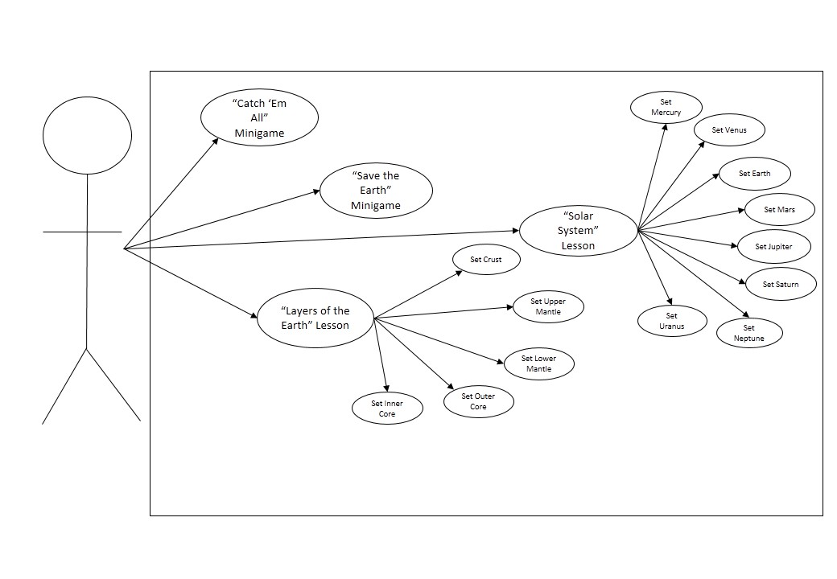***Figure 3.*** Use-Case Diagram of the Application

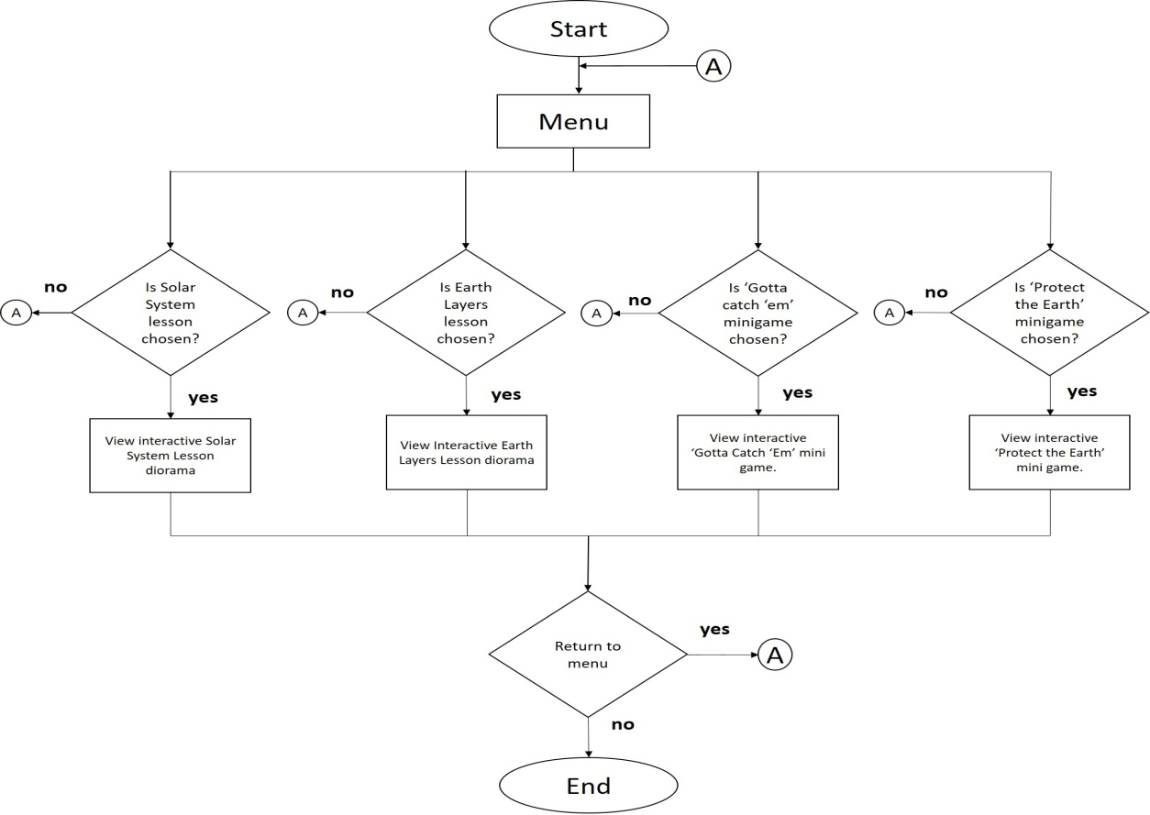**System Flow Chart**

***Figure 4.*** System Flowchart

Shown in Figure 4, the system flowchart displays the process of how the application works. The user will choose between the topics and view the chosen topic in the VR interface. The user will be able to view a diorama based on the topic chosen earlier, and will be able to interact and learn from the diorama. Users can choose to end the topic and it will redirect them back to the main menu. Users can select one of the mini games and if they manage to finish the game, they can either go back to the main menu or replay the game again.

**Hierarchical Input Process Output**

***Figure 5.*** Hierarchical Input Process Output of Eureka

Eureka: VR E-learning Application

The user will select a Lesson Topic

The user will choose to try one of the minigames

Back to Menu

The user will view and interact with the VR environment included in the Lesson Topic

Figure 5 shows the HIPO (**Hierarchical Input Process Output)** of Eureka. The users will then proceed into selecting a Lesson Topic from an interactive Class room-like menu and will be able to learn from the topic they have selected. The topics will load and will provide an interactive diorama of the lesson.

The project aims to develop an interactive Virtual Reality E-learning application that can simulate a certain environment in Science and make their learning experience enjoyable and worth studying.

The application has the following mechanics:

1. The Main Menu will display a classroom-like scenario where the users can walk close to the menu written on the board or find items inside the classroom that will virtually transport them to a topic related to that item.
2. After selecting a topic in menu, users will be virtually transported to a diorama representing the topic. By hovering to objects inside the diorama, information about it will be displayed. Users can also look around and wander around the virtual environment.
3. Users can end the topic by selecting the exit option, or finding the exit portal. Afterwards they will be redirected back to the main menu, wherein they can choose.
4. The Challenge is a short and fun quiz related to the topic. Users will hover to the letter of their choice and will get the result in the end.
5. After taking the challenge, users will be virtually teleported back to the classroom, and topics as well as Challenges that are taken will be marked as “taken”.

**Project Development**

The project development of the study is visualized through Project title and Description and Case Title and Description in Tables 1 and 2.

**Table 1.**

*The Detailed Process for Each Module.*

|  |  |  |
| --- | --- | --- |
| **Project Number** | **Project Title** | **Project Description** |
| 1 | Classroom Menu | This will generate the main menu written in the black board where the user can select and unlock topics, or search around the classroom to find items related to the Topic and be transported to the VR environment of the topic. |
| 2 | Topic Environment | This process will load the VR environment of the topic selected from the Classroom Menu |
| 3 | Mini Games | This process will allow the user to select between “Protect the Earth” and “Gotta Catch Them” mini games. |
| 4 | Settings | This process will generate the options for music, sound, and quality of the graphics of the application |

**Table 2**

*The Use Case procedure of the application*

|  |  |  |
| --- | --- | --- |
| **Use Case Number** | **Project Title** | **Use Case Description** |
| UC01 | Classroom Menu | This use case will begin when the application is selected. The application will be primed up to the Topic Environment Case and Challenges Case. |
| UC02 | Topic Environment | This Use Case will allow the user to choose a topic they would like to learn about. |
| UC03 | Select Challenges | This Use case will allow the user to play games related to the topics they have chosen earlier. Other challenges will be accessible once the user has finished a prerequisite topic |
| UC04 | Start Challenge | This Use Case will begin once a challenge is chosen. |
| UC05 | End Challenge | This Use Case will begin once the user is done with the game in the Challenge Use Case. |

Figure 6 shows how the application was developed

DATA GATHERING

STUDY OF RELATED LITERATURE

APPLICATION DESIGN

APPLICATION DEVELOPMENT

INTEGRATION, TESTING, & DEVELOPMENT

IS IT RUNNING?

EVALUATION

NO

YES

***Figure 6.*** Flowchart for the Application Development

After collecting all the information needed to create the application, the researchers proceeded into creating the application. After integration, testing, and debugging the software, and once it ran successfully, the software was evaluated using ISO 25010.

The application will run in the following requirements: the Android OS version is based on Android 4.4 Kitkat and should not be lower in that version, and the device must have gyroscope and VR-compatibility. Any OS lower than 4.4 and does not have gyroscope is not capable of running the application.

**Operation and Testing Procedures**

The study is about the Development of an Educational Android Application: Eureka that will run in VR-compatible Android Devices. The developers took the following procedures to properly operate the modules of the software as well as to test the *Functionality, Usability, and Reliability* of the application*.*

**Table 3**

*Testing Procedure for Functionality, Usability, and Reliability.*

|  |  |
| --- | --- |
| **Modules** | **Steps Undertaken** |

|  |  |
| --- | --- |
| 1. 3D Game Software | a. Installed the application using the provided apk file.  b. Ran the application.  c. Mounted the smartphone into the VR Box head-mounted display.  d. Worn the VR Box head-mounted display.  e. Connected the Bluetooth controller to the smartphone.  f. Observed the results. |
| 2. Choosing the Lesson | a. Ran the application.  b. Selected a lesson from the menu.  c. Observed the results. |
| 3. Select Solar System lesson | a. Ran the application  b. Selected the Solar System lesson  c. Selected a planet  d. Observe the results. |
| 3. Select Earth Layers lesson | a. Ran the application  b. Selected the Earth Layers lesson  c. Selected a layer  d. Observed the results |
| 4. Play Gotta Catch Them | a. Ran the application.  b. Selected the Gotta Catch Them mini game  c. Caught the planets  d. Shot the planets in the portal  d. Observed the results. |
| 5. Play Protect the Earth | a. Ran the application  b. Selected the Protect the Earth mini game  c. Shot UFO enemies  d. Observed the results. |

_____________________________________________________________________

In installing the application, the user must have gyroscope and VR-compatible hardware. After acquiring the installer, place it in the smart phone that covers the requirements needed for the application to run and run the application. While the app is running, place the smart phone in the VR Glasses.

**Evaluation Procedure**

To determine the acceptability of the application, the researchers used the ISO 25010 evaluation instrument for software that includes the following criteria: Functionality, Usability, and Reliability using a 4-point Likert Scale in the rating system. The researchers gathered 25 respondents composed of Grade 6 students from Las Piñas Elementary School – Central and 5 professionals, and expected to determine the merit, worth and significance of the project based on the criterion that were set as standards.

Frequency was used to determine the result of the evaluation, simple frequency in particular. The evaluation scores from each indicators in the criteria are set in a percentage and is compared towards the rest of the categories to determine which criteria the application excels the most and which criteria should the application need to improve.

Where:

f = Frequency

n= Number of respondents

N = Total Number of respondents

i = Number of response

**Chapter 4**

**RESULTS AND DISCUSSION**

This chapter tackles the Project Description, Project Structure, Project Capabilities and Limitations, and Project Evaluation.

**Project Description**

The study developed the “Eureka: Virtual Learning Classroom”. It is a single user, virtual reality based simulation where the virtual environment is a classroom, where the lessons are based on the K-12 Grade 6 Science curriculum as stated by the Department of Education, particularly during the 4th grading period, in which the topics are about the layers of the Earth and introduction to the Solar System.

The application is supported by any Android smart phone running on Android KitKat 4.4 operating system and the Android smart phone should have a gyroscope sensor. The system was developed using the C# programming language, the IDE used to develop the app was Unity3D, while the models were made using Blender and Metasequoia software.

**Project Structure**

The following figures presented the different scenes of the mobile application “Eureka: Virtual Learning Classroom”.

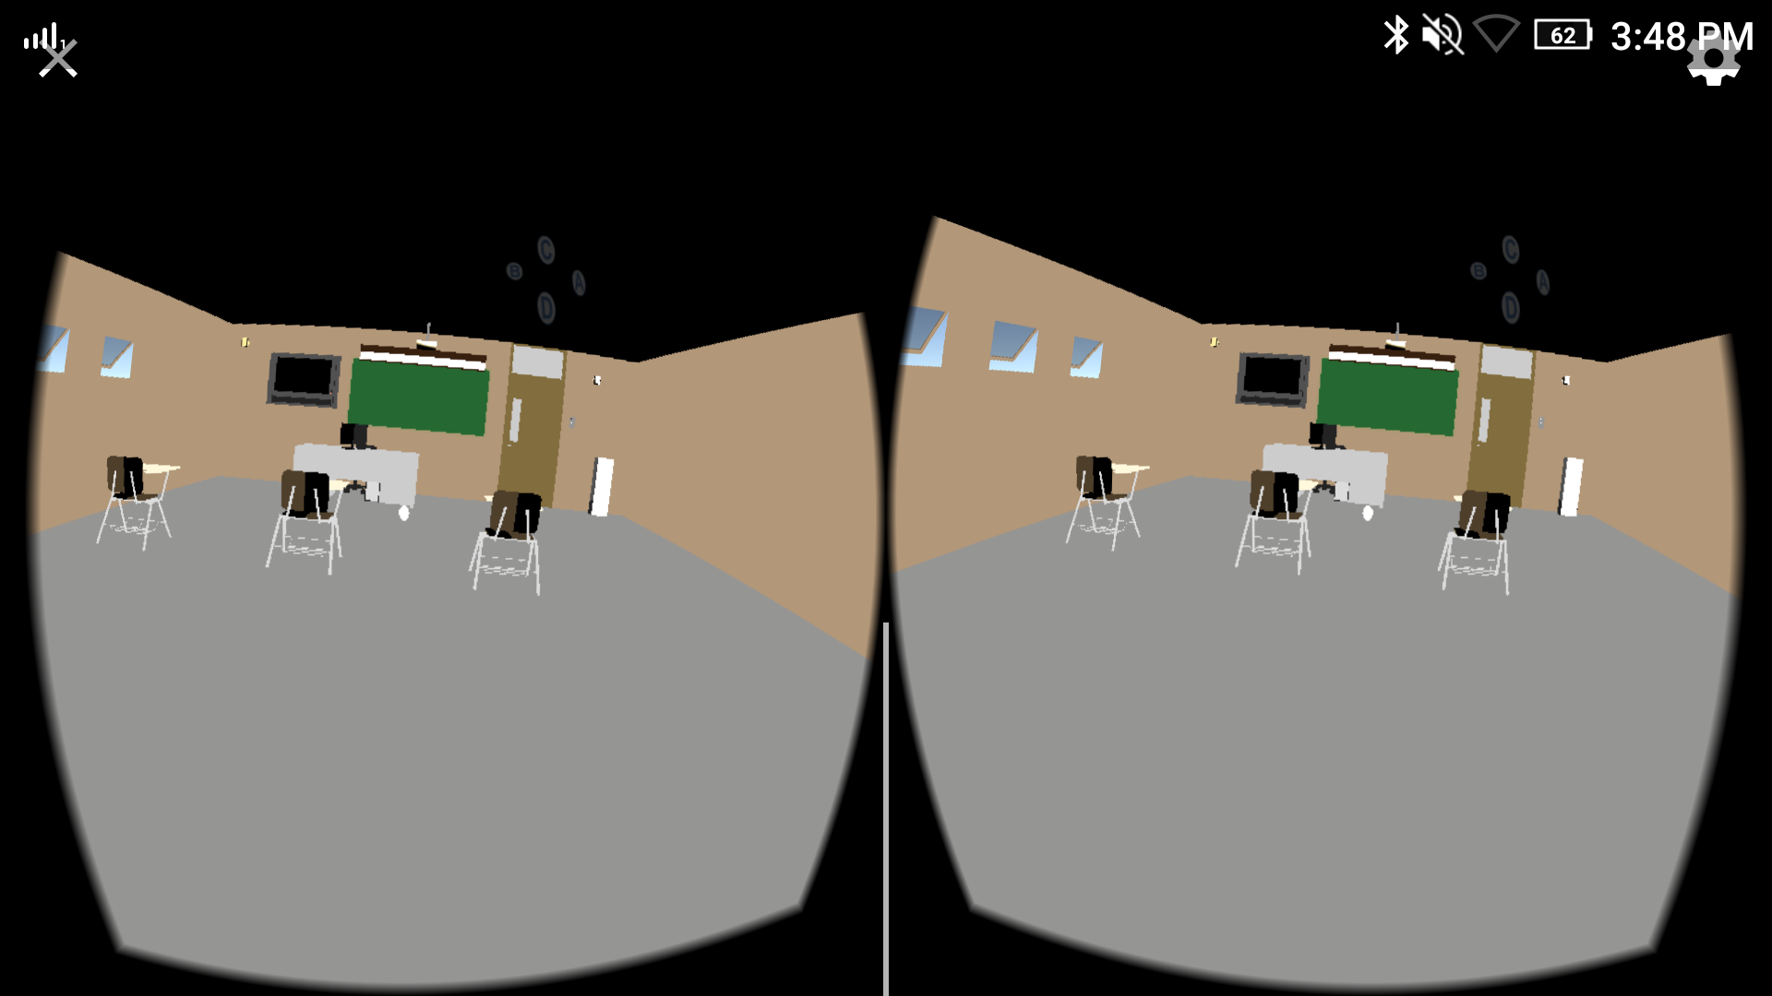

***Figure 7.***The Classroom Interface

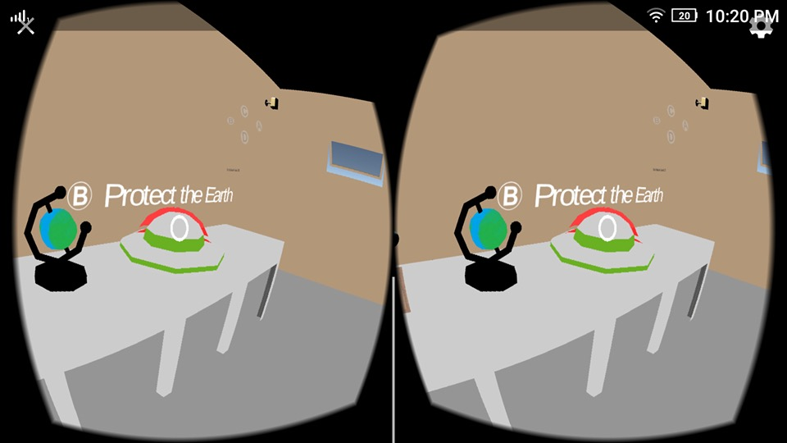

***Figure 8.*** The Interactive Menu where the user has to hover and click the pointer to select an item.

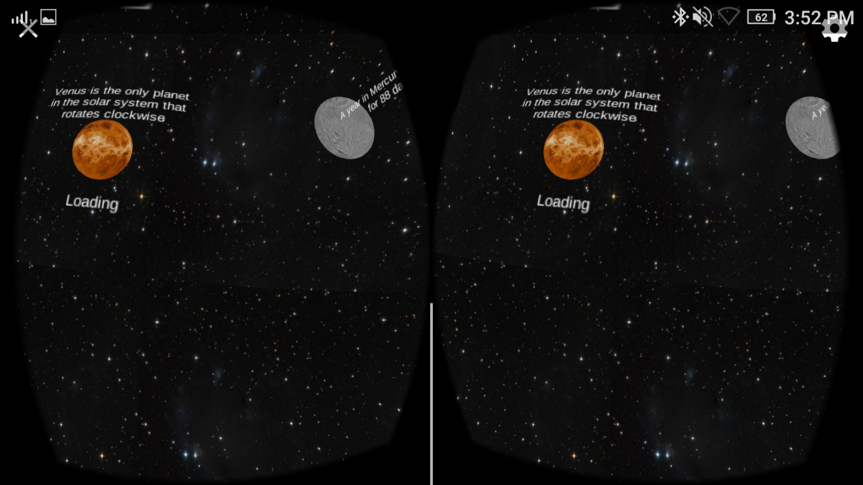

***Figure 9.*** The Loading Screen containing trivia about space

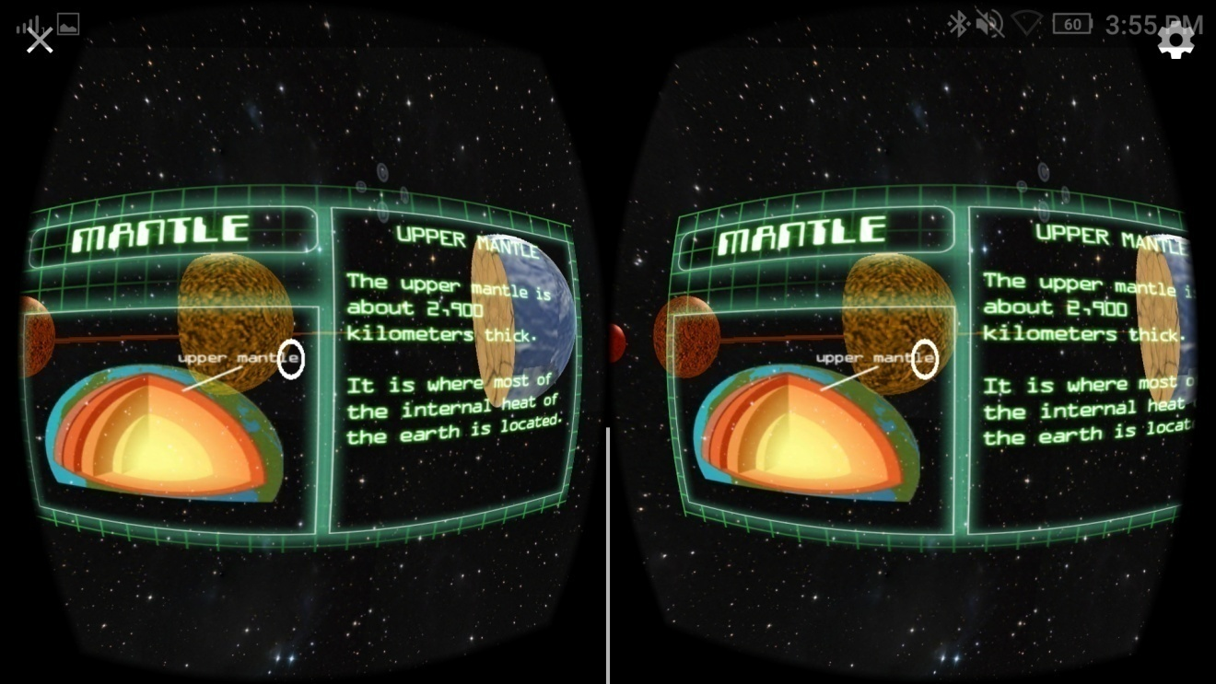

***Figure 10.*** The Status Screen for The Layers Of The Earth, giving details about the selected heavenly body

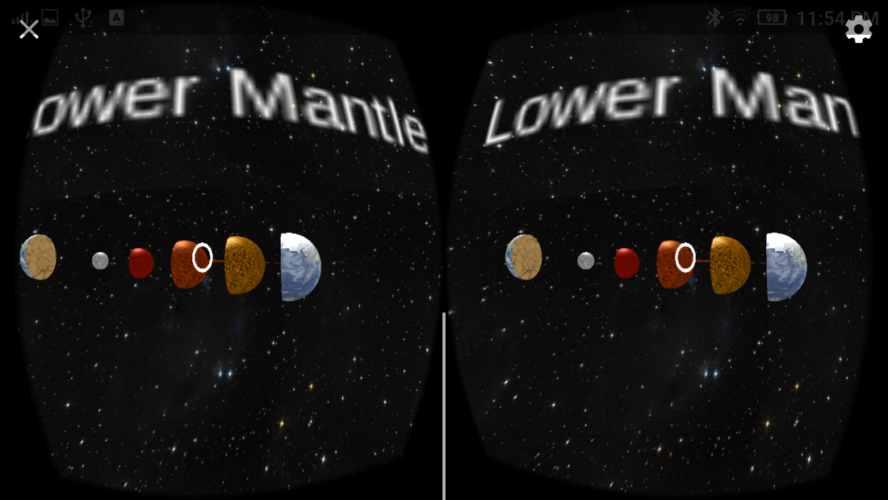

***Figure 11.*** The Layers of The Earth cut in half.

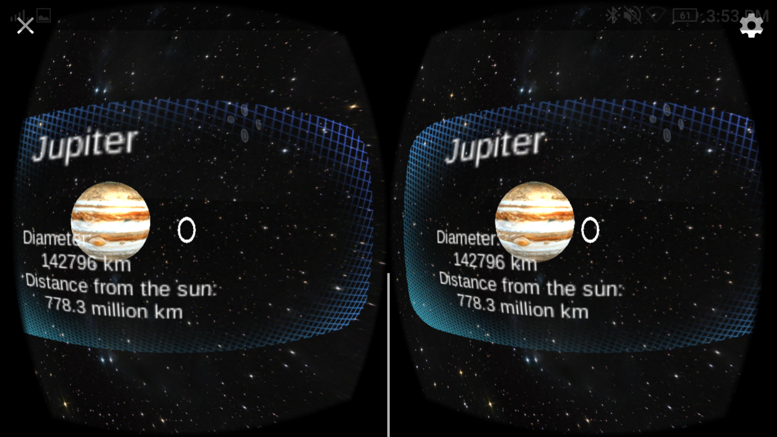

***Figure 12.*** The Status Screen for The Solar System, showing details from each planet.

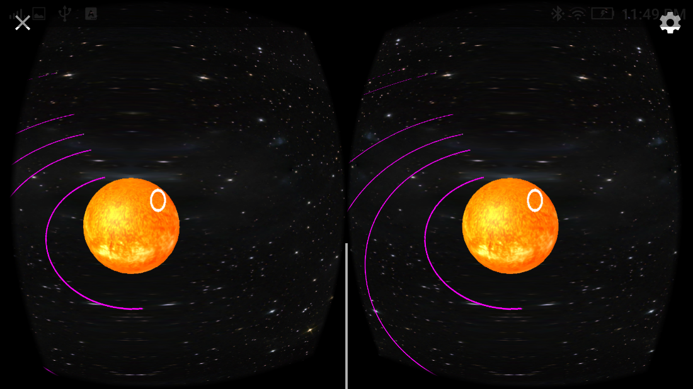

***Figure 13 .*** The Simulation Of The Revolution Of The Planets

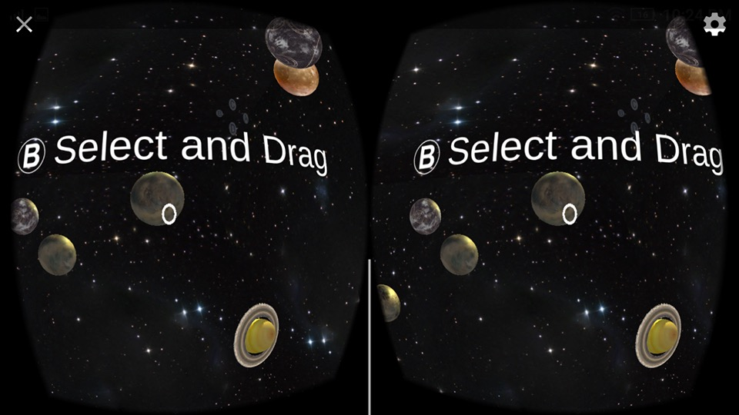

***Figure 14.*** “Gotta Catch Em” Minigame for the Solar System topic.

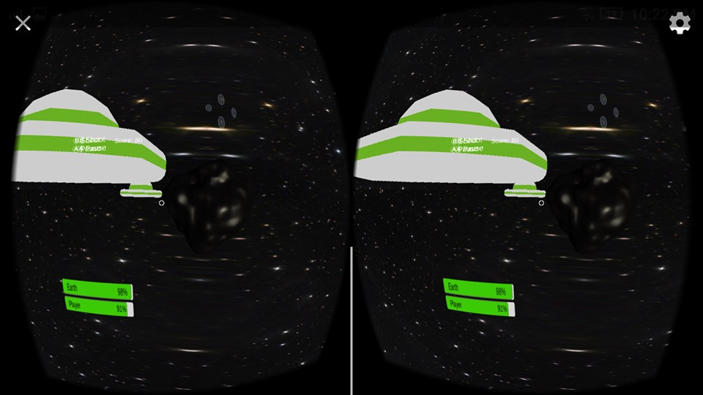

***Figure 15.*** Protect The Earth Mini game for the Layers of the Earth topic.

**Project Capabilities and Limitations**

The following are the capabilities of the developed system:

1. The application could run on Android Smart phones that has a gyroscope.
2. The application allows the user to interact with the scenes and acquire new information through a voice narrator, as a companion with the lessons.
3. The application allows the user to explore outer space and the layers of the Earth through the virtually simulated environment.
4. The user can freely turn a full 360 degrees without altering the application.

These are the limitations of the developed system:

1. The application can only accommodate a single user at a time.
2. As of now, the application has two topics: Earth layers and the solar system.
3. The application requires the use of the Bluetooth controller.
4. The simulation cannot run on other operating systems besides Android.

**Test Results**

The results shown in Table 4 were obtained from the operation and testing procedure undertaken by the researchers. The result showed that the system is functional, reliable, and efficient and usable for the user from the installation of the application, the selection of lessons, to the mini games.

**Table 4**

*Test Results for Functionality, Reliability, Efficiency, and Usability.*

|  |  |
| --- | --- |
| **Test on** | **Results** |

|  |  |
| --- | --- |
| 1. Virtual Reality Environment | a. The system was able to provide a Virtual Reality experience for the user along with the VR Box head-mounted display and the Bluetooth controller. |
| 2. Main Menu System | a. The system was able to provide a main menu through the Virtual Classroom Environment for the selection of lessons and mini games. |
| 3. View the Layers of the Earth | a. The user was able to select the Layers of the Earth lesson. Wherein the user can view each layers of the Earth and successfully go back to the Virtual Classroom. |
| 4. View the Solar System | a. The user was able to select the Layers of the solar system lesson. Wherein the user can view each layers of the Earth and successfully go back to the Virtual Classroom. |
| 5. Play Protect the Earth | a. The user was able to select Protect the Earth mini game. The user can shoot UFO enemies, keep track of the status of the Earth and the user through the health bar, and successfully go back to the main menu. |
| 6. Play Gotta Catch ‘em | a. The user was able to select Gotta Catch Them mini game. The user can catch the planets, shoot them to the portal and successfully go back to the main menu. |

_____________________________________________________________________

**Project Evaluation**

Based on the results of the evaluation, the developed system entitled "Eureka: Virtual Learning Classroom" gained the highest frequency score received in the entire evaluation is under the Functionality category, particularly in the Significance of the system, gaining the highest frequency score of 4, which is “Highly Acceptable”. This concludes that the system provides relevant information about the topics inside the system to the users.

**Table 5**

*Respondent’s Frequency Rating of the Project*

|  |  |  |  |  |  |  |
| --- | --- | --- | --- | --- | --- | --- |
| **Criteria** | | **Frequency** | | | | **Interpretation** |
|  |  | 4 | 3 | 2 | 1 |  |
| **A.** | **Functionality** |  |  |  |  |  |
|  | 1. Compliance | **63%** (19) | **33%** (10) | **3%** (1) | **0%** (0) | Highly Acceptable |
|  | 2. Timeliness | **67%** (20) | **27%** (8) | **7%** (2) | **0%** (0) | Highly Acceptable |
|  | 3. Significance | **80%**  (24) | **13%** (4) | **7%** (2) | **0%** (0) | Highly Acceptable |
|  |  |  |  |  |  |  |
| **B.** | **Reliability** |  |  |  |  |  |
|  | 1. Maturity | **63%** (19) | **30%** (9) | **7%** (2) | **0%** (0) | Highly Acceptable |
|  | 2. Fault Tolerance | **43%** (13) | **47%** (14) | **10%** (3) | 0% (0) | Very Acceptable |
| **C.** | **Usability** |  |  |  |  |  |
|  | 1. Understandability | **63%** (19) | **30%** (9) | **7%** (2) | **0%** (0) | Highly Acceptable |
|  | 2. Easy to Remember | **73%** (22) | **23%** (7) | **3%** (1) | **0%** (0) | Highly Acceptable |
|  | 3. Operability | **63%** (19) | **27%** (8) | **10%** (3) | **0%** (0) | Highly Acceptable |
| **D.** | **Efficiency** |  |  |  |  |  |
|  | 1. Time Behavior | **73%** (22) | **20%** (6) | **7%** (2) | **0%** (0) | Highly Acceptable |
|  | 2. Resource Behavior | **70%** (21) | **30%** (9) | **0%** (0) | **0%** (0) | Highly Acceptable |

Table 5 shows that the system gained the frequency score 4 which is “Highly Acceptable” for almost all the categories aside from Fault Tolerance which gained the frequency score of 3 which is “Very Acceptable”.

In terms of Functionality, all the categories received the highest frequency score of 4, which is “Highly Acceptable”. This indicates that the system is functional and accurate to its objectives.

In terms of Reliability, the sub-category Maturity gained the highest score frequency score of 4, which is “Highly Acceptable”. This means that the system does not have bugs. Under the Fault Tolerance category, the frequency score is 3, which is Very Acceptable”, which concludes that there is a certain level is maintained even when a trouble happens. Overall, the Reliability gained a positive score which leads to the system not terminating when encountering bugs.

In terms of Usability, all indicators received a frequency score of 4, which is “Highly Acceptable”. This indicates that the system is easy to navigate and is user-friendly.

In terms of Efficiency, all indicators received the highest frequency of 4, which is “Highly Acceptable”. This indicates that the system functions in a timely manner.

**Chapter 5**

**SUMMARY OF FINDINGS, CONCLUSIONS, AND RECOMMENDATIONS**

This chapter discusses the summary of findings, conclusions, and recommendations to the study.

**Summary of Findings**

The researchers developed the “Eureka: A Virtual Learning Classroom” to aid students in visualizing their lessons in Science. Through virtual reality, the students can have a better image of the different topics, such as the solar system and the layers of the Earth, and the immersive environment can help the student get involved in the lessons. The mobile app was developed in Unity3D for the game codes and the animations, and C# as the programming language. The 3D assets are created using Metasequoia and Blender software, while the lesson screens are created on Adobe Illustrator and Photoshop.

The researchers verified, tested, and evaluated by gathering responses from 30 respondents, consisting of 25 students from Las Piñas Elementary School – Central and 5 professionals using ISO 25010.

**Conclusions**

Based on the evaluation and findings of tests, the researchers derived the following conclusions:

1. The system was successfully designed such that:
   1. It can select between the two lessons.
   2. It can allow the users play the mini games in the virtual outer space environment.
2. The test results of the developed system showed that it is functional, reliable, efficient, and usable.
3. The respondents rated the system as “Highly Acceptable” which proves that the system enables them to be immersed in the outer space environment.

**Recommendations**

For further enhancements of the system, the developers proposed the following recommendations:

1. Insert more lesson modules that is based on the K-12 science curriculum of the Department of Education.
2. Use a more powerful medium or software in creating the models to make it more realistic.
3. Use a more powerful mobile device with higher specifications to accommodate the quality of the software.

**References**

Blender Foundation,. (2016). *About - blender.org*. *blender.org*. Retrieved 4 October 2016, from https://www.blender.org/about/

Cawood, S. & Fiala, M. (2007). *Augmented reality*. Raleigh, N.C.: Pragmatic Bookshelf.

*Doc:DK/2.6/Manual - BlenderWiki*. (2016). *Wiki.blender.org*. Retrieved 13 September 2016, from https://wiki.blender.org/index.php/Doc:DK/2.6/Manual

Figueiredo, M., Gomes, J., Gomes, C., & Lopes, J. (2014). *Augmented Reality tools for teaching and learning* (1st ed.). Algarve, Portugal: University of Algarve. Retrieved from http://edure.org/EduReJournalVol1N1/EduRe_V1_I1_P2.pdf

Jackson, B. (2016). *Marxentlabs.com*. Retrieved 4 October 2016, from http://www.marxentlabs.com/what-is-virtual-reality-definition-and-examples/

LaValle, S. (2016). *Virtual Reality* (1st ed.). Cambridge, England, United Kingdom: Cambridge University Press. Retrieved from http://msl.cs.uiuc.edu/vr/vrbook.pdf

Magnenat-Thalmann, N. & Thalmaan, D. (1999). *Virtual Reality Software and Technology*(1st ed.). Geneva, Switzerland: MIRALab, Centre Universitaire d'Informatique. Retrieved from http://www.miralab.ch/bibliography/98.pdf

Milgram, P. & Kishino, F. (1994). *A TAXONOMY OF MIXED REALITY VISUAL DISPLAYS* (1st ed.). Fairfax, VA: George Mason University. Retrieved from http://cs.gmu.edu/~zduric/cs499/Readings/r76JBo-Milgram_IEICE_1994.pdf

Nakov, S. (2013). *Fundamentals of Computer Programming with C#*. Veliko, Tarnovo, Bulgaria: Faber Publishing House.

Rabin, S. (2005). *Introduction to game development*. Hingham, MA: Charles River Media.

Thomas, B. (1958). *Walt Disney, the art of animation*. [New York]: [Simon and Schuster].

*Trimble Navigation to buy Google's SketchUp*. (2016). *Reuters*. Retrieved 13 September 2016, from http://www.reuters.com/article/us-trimble-google-idUSBRE83P0V820120426

*What is 3D modeling? - Definition from WhatIs.com*. (2016). *WhatIs.com*. Retrieved 13 September 2016, from http://whatis.techtarget.com/definition/3D-modeling

Wolf, M. (2008). *The video game explosion*. Westport, Conn.: Greenwood Press.

Zamojc, I. (2012). *Introduction to Unity3D*. *Code Envato Tuts+*. Retrieved 13 September 2016, from http://code.tutsplus.com/tutorials/introduction-to-unity3d--mobile-10752

*What is vector graphics? - Definition from WhatIs.com*. (2016).*SearchWinDevelopment*. Retrieved 4 October 2016, from http://searchwindevelopment.techtarget.com/definition/vector-graphics

*Techterms.com*. Retrieved 4 October 2016, from http://techterms.com/definition/vectorgra

Losey, A., (2012), ‘Astornomy’ or ‘astrology’: A brief history of an apparent confusion. *Journal of Astronomica History and Heritage, 15(1),* 42-46.

ISO, “ISO/IEC 25010:2011” Retrieved October 1, 2016 from

http://www.iso.org/iso/catalogue_detail.htm?csnumber=35733

IGN, (2016). *IGN Reacts -John Carmack Makes Virtual Reality Actually Cool - E3 2012 - IGN Video*. *IGN*. Retrieved 4 October 2016, from http://www.ign.com/videos/2012/06/06/ign-reacts-john-carmack-makes-virtual-reality-actually-cool-with-new-head-tracking-device-e3-2012/

*Adobe Illustrator*. (2016). *Wikipedia*. Retrieved 4 October 2016, from https://en.wikipedia.org/wiki/Adobe_Illustrator#History

(2016). Retrieved 2 October 2016, from https://www.nasa.gov/pdf/58277main_Space.Based.Astronomy.pdf

*Blog — Powering the Rift*. (2015). *Www3.oculus.com*. Retrieved 4 October 2016, from https://www3.oculus.com/en-us/blog/powering-the-rift/

Department of Education, (2013). *K-12 Curriculum Guide: Science* (1st ed.). Pasig City, Philippines: Department of Education. Retrieved from http://www.deped.gov.ph/sites/default/files/page/2014/Final%20Science%20CG%203-10%2005.08.2014.pdf

Rowan, K. (2016). *What is Adobe Illustrator Used For? Understanding Vector Images*. *Udemy Blog*. Retrieved 4 October 2016, from https://blog.udemy.com/what-is-adobe-illustrator-used-for/

Weinert, F. (2008). *Copernicus, Darwin, Freud*. Oxford: Blackwell.

**Appendix A**

**EVALUATION INSTRUMENT**

Technological University of the Philippines

College of Science

Mathematics Department

Name: _________________________ Date___________________

**Direction:** Please check the appropriate column corresponding to your evaluation of the study entitled “Eureka: Virtual Learning Classroom” using the scale below.

Numerical Rating Descriptive Rating

4 Highly Acceptable

3 Very Acceptable

2 Acceptable

1 Not Acceptable

|  |  |  |  |  |
| --- | --- | --- | --- | --- |
| Design Criteria | 4 | 3 | 2 | 1 |
| Functionality |  |  |  |  |
| 1. The function meets specification (compliance) |  |  |  |  |
| 2. The system provides up-to-date information and |  |  |  |  |
| presents information in short span of time (timeliness) |
| 3. The system provides relevant information (significance) |  |  |  |  |
| Reliability |  |  |  |  |
| 1. Software has no bugs (maturity) |  |  |  |  |
| 2. A certain system level is maintained even when a trouble  happens (fault tolerance) |  |  |  |  |
| Usability |  |  |  |  |
| 1. Easy to use (understandability) |  |  |  |  |
| 2. Easy to remember |  |  |  |  |
| 3. Allows easy operation management (operability) |  |  |  |  |
| Efficiency |  |  |  |  |
| 1. Provides good response (time behavior) |  |  |  |  |
| 2. Allows effective use of system resources (resource behavior) |  |  |  |  |

Comments/Suggestions _________________________________________________

**Appendix B**

**SAMPLE ANSWERED EVALUATION SHEET**

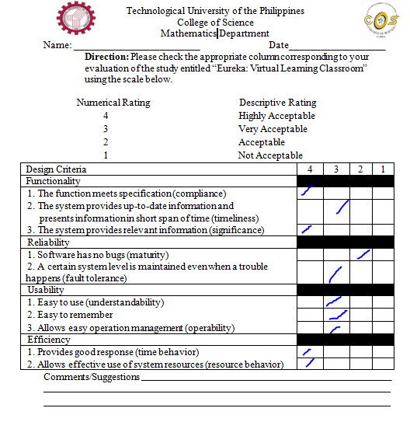

**Appendix C**

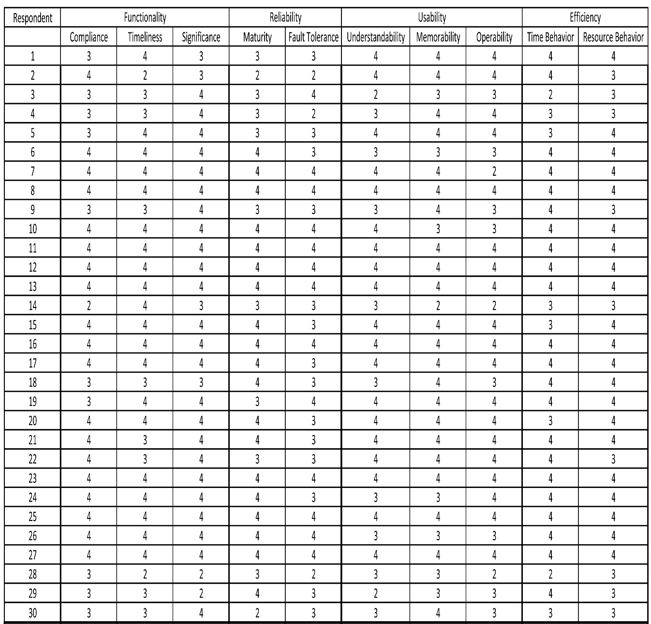**SUMMARY OF EVALUATION RESPONSES**

**Appendix D**

**GANTT CHART**

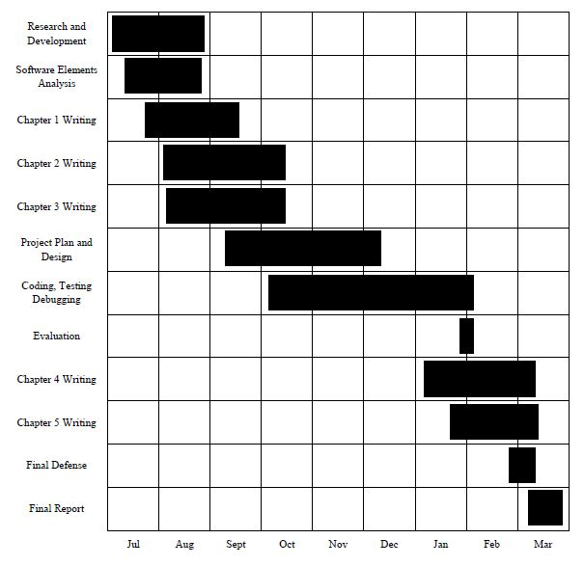

**Appendix E**

**USER’S MANUAL**

A simple guide on how to use Eureka.

**GOAL**

To interact with the lessons and play the mini games in the application.

**HOW TO USE**

* To use the app, click the “Eureka” icon in your mobile home screen.
* On the interactive menu, you can choose between 4 options; “Protect the Earth”, “Layers of the Earth”, “Solar System”, and “Gotta Catch ‘em”.

“Protect the Earth” mini game

* + Select “Protect the Earth” by hovering the indicator on the UFO 3D model on the interactive main menu and press the “B” button on the Bluetooth controller.
  + When redirected to the game play screen, the player must shoot the enemies by hovering the indicator on the UFOs and pressing the “B” button on the Bluetooth controller.
  + To pause the game, press “A” button on the Bluetooth controller
  + The game will end when the health bar of the Earth or the user reaches “0%” or when the user defeats the “mothership”.

“Layers of the Earth” interactive diorama

* Select “Layers of the Earth” by hovering the indicator on the globe 3D model on the interactive main menu and press the “B” button on the Bluetooth controller.
* When redirected to the “Layers of the Earth”, select the Earth found in the outer space environment, this will cut the Earth 3D model in half and will show the different layers of the Earth.
* To view the information screens on each layer, click a desired layer of the Earth by pressing “B” button on the Bluetooth controller.
* To close the Earth 3D model, click the other half of the Earth 3D model that is found next to the Inner Core 3D model to its left.
* To exit “Layers of the Earth” interactive diorama, find the portal and hover the indicator over the portal and press “B” button.

“Solar System” interactive diorama

* Select the “Solar System” by hovering the indicator on the 3D Solar System model on the interactive main menu and by pressing “B” on the Bluetooth controller.
* To view and hear the information screen of the planets, click the planet.
* To move to the next planet, press “D” or “C” on the Bluetooth controller.
* To view the rotation of the planets around the sun, hover the indicator over the sun and press “B” button to view to view the revolution of the planets around the sun.
  + Use the analog to zoom in and out of the outer space to get a better view of the planets.
  + To stop the rotation, there are two options:
    - Press the “B” button when the indicator is hovering on the sun.
    - Wait for the planets to complete a 360° rotation around the sun.
* To exit the “Solar System” interactive diorama, find the portal and hover the indicator over the portal and press “B” button in the Bluetooth controller.

“Gotta Catch ‘Em”

* Select “Gotta Catch ‘Em” mini game by hovering the indicator on the 3D computer screen monitor model on the interactive main menu and by pressing “B” on the Bluetooth controller.
* To catch the planets, press and hold “B” button on the Bluetooth controller and to navigate, use the analog found also on the Bluetooth controller. This will allow the user to drag the planet to different places.
* Place the planet in the portal by releasing “B” button when the planet is over the blue portal. The portal will not accept the wrong planet.
* To exit, hover the indicator over the portal which says “Go Home” and press “B” button on the Bluetooth controller.

**­­­Appendix F**

**CURRICULUM VITAE**

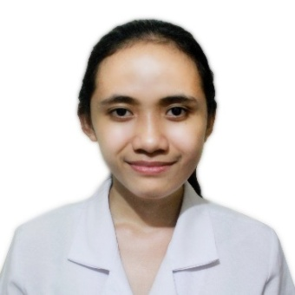

**PAULINE DALISAY ESCALONA**

Blk 12 Lot 40, Almond Drive St., SHIV Molino 6, Bacoor, Cavite

Contact: 09494872891

Email: **papoulapauline@gmail.com**

**EDUCATIONAL BACKGROUND**

**TERTIARY TECHNOLOGICAL UNIVERSITY OF THE PHILIPPINES – MANILA**

Ayala Boulevard, Ermita, Manila

College of Science

**Bachelor of Science in Computer Science**

2013- 2017

**SECONDARY Bacoor National High School Molino Annex - Special Science Course**

Burol, Molino 1, Bacoor, Cavite

2009-2013

**SKILLS**

**Language:** C, C++, Java, Visual Basic.net, Python 2.7, MySQL

**Web development Essentials:** HTML5, CSS, JavaScript, Bootstrap, CodeIgniter

**Database:** MySQL

**Game Engine:** Unity 5.4.1

**Design and UI:** Adobe Photoshop, Illustrator, Animate

**INTERNSHIP**

**FourthShift Global**

19/F Trafalgar Plaza, H.V. Dela Costa St., Salcedo Village Makati City, Philippines

Web Designer and Animator (Web Development)

April – May 2016

**PROJECTS AND ACCOMPLISHMENTS**

* **Eureka: Virtual Learning Classroom**

Virtual Reality Android App using Unity Engine and C#

*Thesis*

October 2016 – Present

* **TUP Computer Association Integrated System**

Application using Java SE

*Course Requirement*

November 2016

* **TUP Academic Cup 2016 Web Programming Contest**

*Semifinalist*

February 9, 2016

**AFFILIATIONS**

Member, VR Philippines (2016 - Present)

Treasurer, TUP Math Society (2015 – 2016)

Member, TUP Computer’s Association (2013 – 2017)

Member, TUP Math Society (2013-2015)

**SEMINARS AND EVENTS ATTENDED**

**Smart School Program: Websmart Training**

Smart Communications Inc.

Colegio San Juan De Letran,

Intramuros, Manila

May 25-28, 2012

**Python for the Curious**

Google Women Techmakers 2015

Google Inc. and PyLadies

iAcademy, Makati City

March 28, 2015

**Polymer - Google Web Library**

Google I/O Extended 2015 Manila

Google Inc.

De La Salle University, Manila

July 16, 2015

**Web Design Conference 2015**

Technological University of the Philippines – Manila

IRTC Conference Hall

November 27, 2015

**Career Symposium**

Technological University of the Philippines – Manila

IRTC Conference Hall

November 27, 2015

**Imagine Camp 2016: Seminar**

Technological University of the Philippines – Manila

IRTC Conference Hall

February 9, 2016

**Polymer Workshop**

Google Women Techmakers 2016

Google Inc.

De La Salle University, Manila

March 19, 2016

**Cloud Salesforce**

TUP – Manila

DOST Room, College of Science Building

February 11, 2017

**VRPH Meetup 2 – Extending the Possibilities of PC VR**

VR Philippines

SparkLab Innovation Center

February 25, 2017

**CHARACTER REFERENCE**

**Michael John Barroso Esteban**

Application Development Associate Manager/ServiceNow Capability Lead

Accenture Philippines Inc.

0917 835 7209

**May S. Garcia**

SIT Coordinator & Professor

Technological University of the Philippines - Manila

09224712704

**Ma. Teresa Mandi**

Professor

Technological University of the Philippines Manila

0932307577

**ADRIAN SIMBULAN FELIX**

1737-C Kahilum 1 St,Pandacan, Manila

Mobile No: 09219602995 / 09174318514

Home No: 2571693

Email:ian.felix18@gmail.com

______________________________________________________

**EDUCATIONAL ATTAINMENT**

**TERTIARY TECHNOLOGICAL UNIVERSITY OF THE PHILIPPINES - MANILA**

Ayala Blvd., Ermita, Manila

College of Science

**Bachelor of Science in Computer Science**

2013 – Present

**SECONDARY REPUBLIC INSTITUTE**

2rd Honourable Mention

2009-2013

**TECHNICAL SKILLS**

* Mobile VR game application development
* Application programming
* Web development
* Basic Networking
* Basic Photoshop

**Programming:** Java, C#, Visual Basic, C, HTML, PHP, CSS, JavaScript

**Application:** Visual Studio 2015, NetBeans 8.0.2, Unity 5.4.1

**PRE-PROFESSIONAL EXPERIENCE**

**IT Intern**

Technical and Help Desk Support

Cosmic Digital Universe

1360 Leon Guinto Sr. St. Ermita, Manila

April 2016 – May 2016

**PROJECTS AND ACCOMPLISHMENTS**

* **Eureka : Virtual Learning Classroom**

Thesis, C# Programmer / Team Leader

2016-Present

* **Math Society Desktop and Web Application**

Project, Java and HTML/PHP Programmer

January 2016 – March 2016

* **Web Development Competition**

Participant – Semi-finalist

February 26, 2016

* **Java Programming Competition**

Contestant

November 28, 2014

**SEMINARS AND EVENTS ATTENDED**

**Startup Workshop**

Department of Science and Technology

Bayview Park Hotel, Manila

June 10, 2015

**Social Engineering**

DOST Room, Technological University of the Philippines, Manila

February 8, 2017

**VRPH Meet up 2 – Extending the Possibilities of PC VR**

VR Philippines

SparkLab Innovation Center, Maginhawa, Quezon City

February 25, 2017

**AFFILIATIONS**

* TUP – Manila Math Society

**Business Manager,** 2015-2016

* Republic Institute Cyber Society

**President,** 2012-2013

**REFERENCE**

**May Garcia**

SIT Coordinator/Professor, Technological University of the Philippines - Manila

09224712704

**Michael John Barroso Esteban**

Application Development Associate Manager/ServiceNow Capability Lead, Accenture Philippines Inc.

09178357209

**Melandres Arce**

IT Security Senior Analyst, Accenture Philippines Inc.

09228714389

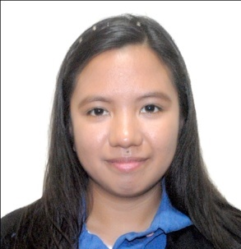**JANNIE JOYCE DE GUZMAN PALLERA**

151 Pag-Asa 2, Imus, Cavite

09151888667

pallera.janice@gmail.com

**EDUCATIONAL BACKGROUND**

**Tertiary** **TECHNOLOGICAL UNIVERSITY OF THE PHILIPPINES – Manila**

Ayala Boulevard, Ermita, Manila

Bachelor of Science in Computer Science

2013 – Present

**Secondary UNIDA NEHEMIAH CHRISTIAN ACADEMY**

Sta. Rosa 2, Noveleta, Cavite

2009-2013

**SCHOLARSHIP**

City of Imus Scholarship Program

2014-2015

**INTERNSHIP**

**Fourth Shift Global Inc.**

19th  Flr. Unit C., Trafalgar Plaza H.V Dela Costa St. Salcedo Village,

Makati City

April 2016 – May 2016

UI/UX Developer

**PROJECTS AND ACCOMPLISHMENTS**

**Eureka: A Virtual E-Learning Classroom**

Thesis – 3D Asset Developer, Information Screen

October 2016 – Present

**TUP ITSO IP Audit System**

Web-based: Front-end developer using PHP and MySQL

Stand-alone: Front-end developer using Java SE and MySQL

*Course Requirement*

November 2015

**TUP Academic Cup 2016 Web Programming Contest**

*Champion*

February 19, 2016

**SKILLS**

**Languages and Technologies: Java SE**, **Visual Basic.net**,**C, C#**, **Python 2.7**, **MySQL, PHP,** Web Development Essentials(**HTML5, CSS,JavaScript, Bootstrap, CodeIgniter**),Android Application Development(**Unity 3D**), 3D Computer Graphics (**Blender, Metasequoia**)

**AFFILIATIONS**

**Tertiary** **Member, TUP Computer’s Association (COMPASS)**

Technological University of the Philippines – Manila

June 2013 – present

**Member, TUP Artists Society (TUPAS)**

Technological University of the Philippines – Manila

June 2013-2015

**Secondary Staff Writer, The Nehemians**

Unida Nehemiah Christian Academy

2011– 2013

**Junior Commander, UNCA Marshalls**

Unida Nehemiah Christian Academy

2012-2013

**SEMINARS ATTENDED**

**VRPH Meet up #2 – Extending the Possibilities of PC VR**

VR Philippines

SparkLab Innovation Center, Maginhawa, Quezon City

February 25, 2017

**Social Engineering**

DOST Room, College of Science

Technological University of the Philippines, Manila

February 8, 2017

**Google I/O Extended 2016 Manila**

Google Inc.

Ateneo de Manila University, Quezon City

July 2, 2016

**Google Women Techmakers 2016**

Google Inc.

De La Salle University, Manila

March 18, 2016

**Imagine Camp 2016: Seminar**

IRTC Conference Hall, Technological University of the Philippines, Manila

February 9, 2016

**Web Design Conference 2015**

IRTC Conference Hall, Technological University of the Philippines, Manila

November 27, 2015

**Career Symposium**

IRTC Conference Hall, Technological University of the Philippines, Manila

November 27, 2015

**Google I/O Extended 2015 Manila**

Google Inc.

De La Salle University, Manila

July 16, 2015

**Google Women Techmakers 2015**

Google Inc.

iAcademy, Makati City

March 28, 2015

**CHARACTER REFERENCES**

**Antonette V. Sarinas**

Court Employee, RTC, Branch 88, Cavite City

nethvalsar@yahoo.com

09398406581

**Ian Carlo A. Ordoñez, CPA**

Financial Statement Assurance Senior Associate

icaordonez22@gmail.com

09151723709

**Michael John B. Esteban**

Application Development Associate Manager/ServiceNow Capability Lead

Accenture Philippines Inc.

09178357209